DataCo Supply Chain
Data Analysis — Mini Project
Power BI Dashboard Documentation
180K+  Total Records | 5  Pages Built | 6  Tables Used | 20+  Visuals

Tool: Microsoft Power BI Desktop | Dataset: DataCoSupplyChain.csv
Source: Kaggle Supply Chain Dataset | Year Range: 2015 – 2018

TABLE OF CONTENTS

1. Project Overview
2. Data Preprocessing
2.1 Data Normalization — Table Split
2.2 Data Cleaning Steps
3. Data Modelling in Power BI
3.1 Star Schema
3.2 Calculated Columns Added
3.3 DAX Measures Table
4. Dashboard Pages
4.1 Executive Analysis
4.2 Regional Analysis
4.3 Customer Analysis
4.4 Profit Analysis
4.5 Shipment Analysis
5. Advanced Features — Bookmark & Drill-through
6. Key Insights & Findings
7. Presentation Notes & Q&A

1 | Project Overview  Background, objectives and dataset summary

The DataCo Supply Chain project is a mini data analysis assignment that demonstrates end-to-end data processing and business intelligence using Microsoft Power BI. The raw dataset is a CSV file containing over 180,000 supply chain order records from 2015 to 2018 across multiple global markets.

The objective was to transform this raw data into an interactive, multi-page Power BI dashboard that gives business stakeholders clear, actionable insights across four key domains — executive performance, regional distribution, customer behaviour, and shipping efficiency.

Dataset Summary
Source file: DataCoSupplyChain.csv (Kaggle Supply Chain dataset)
Records: 180,000+ orders
Time span: 2015 to 2018
Markets: Europe, North America, Latin America, Africa, Asia, Oceania
Tool used: Microsoft Power BI Desktop
Preprocessing: Microsoft Excel — Power Query Editor

2 | Data Preprocessing  Steps taken in Excel Power Query before loading into Power BI

All preprocessing was performed in Microsoft Excel using the Power Query Editor before the data was loaded into Power BI. The steps are documented below in order.

2.1 Loading the Dataset
Open Excel and import the CSV DataCoSupplyChain dataset:
- Go to Data tab → From Text/CSV
- Select the DataCoSupplyChain.csv file
- Before loading, click Transform Data to open Power Query Editor

2.2 Data Normalization — Table Split
The master dataset was a single wide table. To improve performance and follow database normalisation principles, the master table was split into 6 focused tables. Each table was created by taking a Duplicate of the master and then using Home → Choose Columns to keep only the relevant fields.

Table Name | Type | Description
SalesDetails (OrderDetails) | Fact Table | Core table — contains all order details, sales amounts, discounts and profit figures
ShippingDetails | Dimension | Shipping mode, delivery status, late delivery risk, actual vs scheduled days
ProductDetails | Dimension | Product name, category ID, price and stock availability
StoreDetails | Dimension | Department name, market and store location details
CustomerDetails | Dimension | Customer name, city, country, segment and fraud status
CategoryDetails | Dimension | Product category name linked to products

2.3 Data Cleaning Steps
The following cleaning operations were applied to the tables in Power Query:

- Corrected data types for all columns
- Sales, discount, and price columns changed to Currency type
- Date columns corrected to Date/Time format
- Corrected column names to use meaningful, consistent naming format
- Combined CustomerFName and CustomerLName into a single full name column, then deleted both source columns
- Removed duplicate rows from Category, Customer, and Product tables
- Removed rows where Order ZipCode was null
- Corrected Stock Availability values — changed 0 and 1 to Available and Not Available
- Corrected Late Delivery Risk values — changed 0 and 1 to Low Risk and High Risk
- Applied PROPER() / Capitalize Each Word formatting to text columns for consistency

3 | Data Modelling in Power BI  Star schema, calculated columns and DAX measures

3.1 Loading Data into Power BI
- Get Data → Excel Workbook → select the preprocessed Excel file
- Select all 6 tables in the Navigator panel and click Load

3.2 Star Schema — Relationships
In the Model View, a Star Schema was created by connecting the SalesDetails Fact Table to each Dimension table using the common key columns. This structure ensures efficient filtering and accurate aggregation across all visuals.

Fact Table | Dimension Table | Join Key
SalesDetails | ShippingDetails | Order Id
SalesDetails | ProductDetails | Product Card Id
SalesDetails | StoreDetails | Department Id
SalesDetails | CustomerDetails | Customer Id
ProductDetails | CategoryDetails | Category Id

3.3 Calculated Columns Added to SalesDetails
The following columns were created using DAX in the SalesDetails table:

- Year — extracted from Order Date for year-level filtering
- End of Month — date truncated to month end for trend charts
- End of Quarter — date truncated to quarter end
- Month Name — full month name for axis labels
- Profit Tier — classifies each order: High (ratio ≥ 0.4), Medium (0.2–0.39), Low (0–0.19), Loss (< 0)
- Discount Tier — classifies each order: No Discount (0%), Low (1–10%), Medium (11–20%), High (> 20%)
- Gross Profit % — Profit Per Order divided by Non-Discounted Sales

3.4 DAX Measures Table
All DAX measures were stored in a dedicated Measure Table (best practice) to keep the data model clean and organised. Key measures include:

Measure Name | DAX Formula / Description
Total Orders | COUNT(SalesDetails[Order Id])
Total Qty Sold | SUM(SalesDetails[Order Quantity])
Orders Completed | CALCULATE([Total Orders], SalesDetails[Order Status]="Complete")
Profitable Orders | CALCULATE([Total Orders], SalesDetails[Profit Per Order] > 0)
Avg. Profit | AVERAGE(SalesDetails[Profit Per Order])
Discounted Revenue | SUM(SalesDetails[Discounted Total])
Fraud Rate % | DIVIDE(CALCULATE([Total Orders], CustomerDetails[Fraud Status]="Fraud"), [Total Orders])
Avg. Loss | AVERAGEX(FILTER(SalesDetails, SalesDetails[Profit Per Order] < 0), SalesDetails[Profit Per Order])
Discount ROI | DIVIDE(SUM(SalesDetails[Profit Per Order]), SUM(SalesDetails[Item Discount]))

4 | Dashboard Pages  Page-by-page visual breakdown with screenshots

4.1 Executive Analysis
The Executive page provides a high-level summary of the entire business — designed for a manager or CEO who needs the key numbers at a glance. It is the landing page of the dashboard.

KPI Cards (6 metrics)
639K  Total Orders | 1M  Total Qty Sold | 211K  Orders Completed | 515K  Profitable Orders | 53.00  Avg. Profit | 115.2M  Discounted Revenue

Visuals on this page
- Discount Vs Non-Discount Trend (Line chart) — compares discounted vs non-discounted revenue month by month from 2015 to 2018. Shows a sharp drop in 2018.
- Profit Per Order VS Product (Treemap) — products sized by total profit. Field & Stream Sportsman leads at 2.74M.
- Fraud Status VS Order Region (Bar chart) — Western Europe has the highest fraud count at nearly 3K. Correctly uses bar chart (not funnel) for regional comparison.
- Profit & Loss VS Discount Rate (Clustered column) — shows average profit (red) and average loss (orange) at each discount rate level. Uses AVERAGE not SUM for ratio accuracy.
- Year slicer — filters entire page by year for time-period comparison.

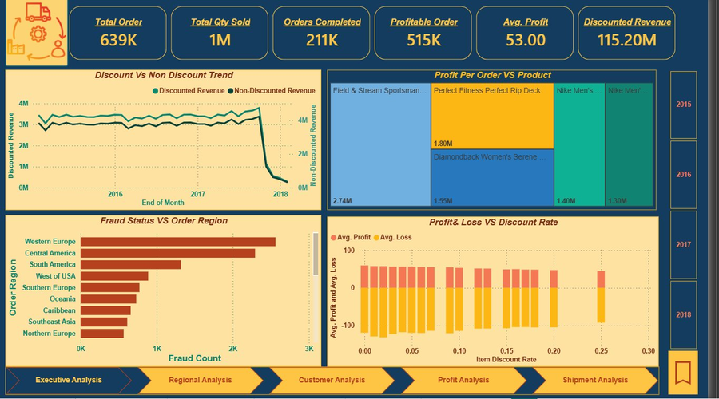
Figure 1 — Executive Analysis page

4.2 Regional Analysis
The Regional page provides a geographic view of order distribution across global markets using an interactive bubble map.

Visuals on this page
- Order VS Region (Bubble Map) — bubble size represents order count per region. Europe has the largest bubble, confirming it as the dominant market. Latin America and North America follow.
- Department slicer (right panel) — filters the map by product department (Apparel, Fan Shop, Fitness, etc.) to show which regions buy which product types.
- Drill-through enabled — right-clicking a region on the Fraud chart in Executive Analysis drills through to this Regional page, filtered to that region's order detail.

Key insight: Europe is the largest market by order volume. Western Europe also had the highest fraud count — confirming that high-volume regions carry higher fraud exposure.

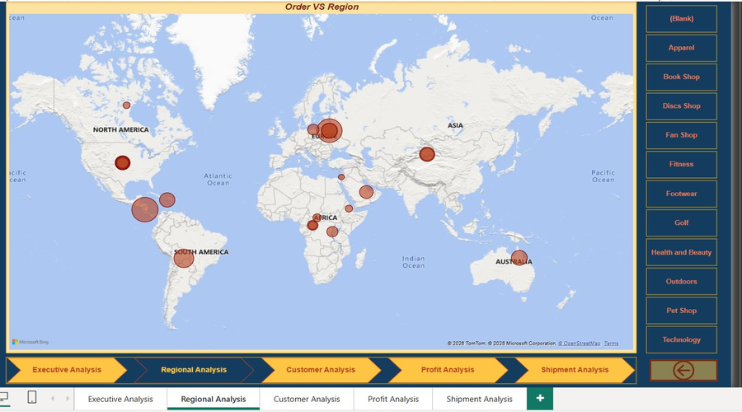
Figure 2 — Regional Analysis page

4.3 Customer Analysis
The Customer page answers three questions: who are the best customers, which segments are most profitable, and where is fraud most concentrated?

Visuals on this page
- Fraud Rate by Customer City (Bar chart) — uses a Fraud Rate % measure (not raw count) so cities of different sizes are fairly compared. Pittsburg has the highest rate at ~20%.
- Avg Sales by Segment (Card visuals) — Consumer: 180.65, Corporate: 179.96, Home Office: 179.31. Shows all three segments have similar average order values.
- Profitable Order VS Segment (Donut chart) — Consumer = 51.86%, Corporate = 30.4%, Home Office = 17.74%. Consumer is the dominant segment by profitable order count.
- Top 10 Customers (Matrix) — ranked by Avg. Sales. Mary Smith leads with 87,366 orders and 15.6M in total sales. Conditional formatting diamonds highlight above/below average performance.
- Top Customer summary card — shows single highest avg. sales customer (Mary Smith, 179.28 avg).
- Segment slicers (Consumer / Corporate / Home Office) — filter all page visuals instantly.

Key insight: Pittsburg has a fraud rate of ~20% — 1 in 5 orders is flagged. Targeted fraud verification for high-risk cities would reduce business losses.

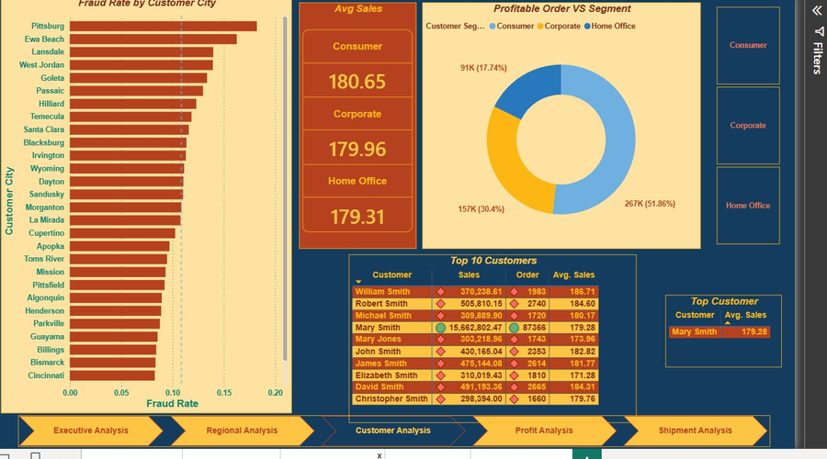
Figure 3 — Customer Analysis page

4.4 Profit Analysis
The Profit page is the most analytically rich page. It uses advanced visuals including a Waterfall chart and a cross-tabulated matrix built from custom DAX calculated columns.

Visuals on this page
- Profit Per Order VS Department (Waterfall chart) — each green bar shows a department's cumulative contribution to total profit. Fan Shop leads at 5.6M, Apparel 3.5M, Golf 2.4M. Running total shown as blue bar at 13.8M.
- Profit Ratio VS Discount Rate (Scatter chart) — Item Discount Rate on X-axis, Average Profit Ratio on Y-axis. Shows the relationship between discount level and profit margin.
- Avg. Profit by Year (Line chart) — profit peaked in 2017 (~57) then dropped sharply in 2018 (~42), confirming 2018 as a difficult performance year.
- Discount Tier VS Profit Tier (Matrix) — cross-tabulates the two DAX calculated columns. At High discount level: 228,456 profitable orders but 53,760 loss orders. Shows discounting has mixed results — effective for some products but value-destroying for others.

Profit Tier | High Discount | Medium Discount | No Discount
Profit | 228,456 | 258,507 | 28,510
None | 1,779 | 2,082 | 270
Loss | 53,760 | 59,400 | 6,545
Discount Tier VS Profit Tier matrix — data from dashboard

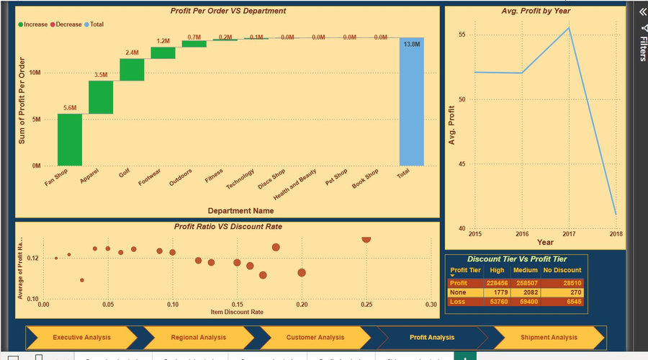
Figure 4 — Profit Analysis page

4.5 Shipment Analysis
The Shipment page focuses on delivery performance, shipping mode risk, and uses Power BI's built-in AI Key Influencers visual to automatically identify what drives late delivery risk.

Visuals on this page
- Late Delivery Risk VS Shipping Mode (100% Stacked bar) — First Class: 95.32% High Risk, Second Class: 76.63%, Same Day: 45.74%, Standard Class: 38.07% (lowest risk). First Class is counterintuitively the worst performing mode.
- Transaction Type VS Delivery Status (Clustered column) — DEBIT has most late deliveries (40K) but also most orders. All transaction types show similar delivery status distributions.
- Order Count VS Shipping Mode (Area chart) — Standard Class dominates with 108K orders, Second Class 35K, First Class 28K, Same Day 10K.
- Key Influencers (AI Visual) — Power BI's machine learning visual identifies that Shipping Mode = First Class increases late delivery likelihood by 2.04x compared to other modes. Second Class increases it by 1.55x. No coding required.

Shipping Mode | High Risk % | Low Risk % | Order Count
First Class | 95.32% | 4.68% | 28K
Second Class | 76.63% | 23.37% | 35K
Same Day | 45.74% | 54.26% | 10K
Standard Class | 38.07% | 61.93% | 108K
Late delivery risk breakdown by shipping mode

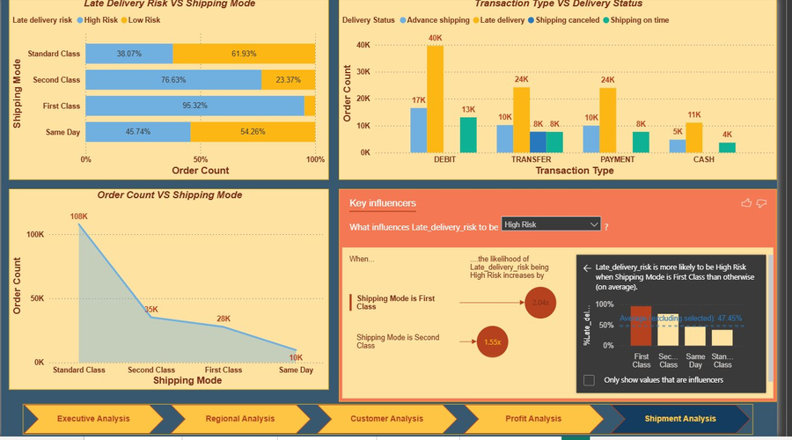
Figure 5 — Shipment Analysis page

5 | Advanced Features  Bookmark and Drill-through implementation

5.1 Bookmark — Best Profit Year (2017)
A bookmark was added to the Executive Analysis page to quickly filter to 2017, which was the most profitable year in the dataset (Avg. Profit ~57).

How it works
- The Year slicer on the Executive page is set to 2017
- A bookmark named 'Best Year 2017' was saved capturing this filter state
- A button on the Executive page is linked to this bookmark
- Clicking the button instantly filters the entire page to show 2017 data only — no manual slicer interaction needed

How to create this bookmark
- Set the Year slicer to 2017 on the Executive page
- Go to View → Bookmarks Pane → Add
- Name it 'Best Year 2017' — right-click → Update if you adjust the view
- Insert a button: Insert → Buttons → Blank. Label it 'View 2017 Peak'
- Set button Action → Type: Bookmark → Bookmark: Best Year 2017

Why this is useful: Stakeholders can jump directly to the most profitable year's performance with one click, without manually adjusting the slicer each time they open the report.

5.2 Drill-through — Fraud to Regional Analysis
A drill-through was applied from the Fraud Status VS Order Region bar chart on the Executive page to the Regional Analysis page. When a user right-clicks a region bar, they can drill through to see that region's order distribution on the map.

How it works
- On the Regional Analysis page, Order Region is placed in the Drill-through well in the Visualizations pane
- This makes Order Region the drill-through key for that page
- On the Executive page, right-click any region bar in the Fraud chart → Drill through → Regional Analysis
- The Regional page opens filtered to only that region's orders
- Power BI automatically adds a back arrow button on the Regional page to return to Executive Analysis

How to set it up
- Go to the Regional Analysis page in Power BI
- In the Visualizations pane, find the Drill through section (below Filters)
- Drag Order Region field into the 'Add drill-through fields here' well
- Navigate to Executive Analysis — right-click a bar in the Fraud chart → Drill through → Regional Analysis

Why this is useful: Instead of manually filtering, a user investigating fraud in Western Europe can right-click that bar and instantly see Western Europe's full geographic order breakdown on the map.

6 | Key Insights & Findings  Business conclusions drawn from the dashboard analysis

6.1 Revenue & Profitability
- The business generated 115.2 million in discounted revenue across 639,000 orders from 2015 to 2018
- 80% of all orders (515K out of 639K) are profitable — a strong base performance
- Revenue was stable from 2015 to 2017 then dropped sharply in 2018 — this decline affects every metric and requires investigation
- Average profit per order peaked in 2017 at ~57 and fell to ~42 in 2018

6.2 Discounting Strategy
- At every discount level, significant average losses occur alongside profits
- 228,456 orders at High discount levels are still profitable — but 53,760 are making a loss
- Discounting is not uniformly harmful but its impact varies significantly by product — the business needs product-level discount rules
- Fan Shop and Apparel departments contribute the most to total profit (5.6M and 3.5M respectively)

6.3 Customer & Fraud
- Pittsburg has the highest fraud rate at ~20% — 1 in 5 orders from that city is flagged
- Western Europe has the highest absolute fraud count (~3K) — consistent with being the largest order region
- Consumer segment drives 51.86% of all profitable orders
- Mary Smith is the single highest-value customer with 87,366 orders and 15.6M in total sales

6.4 Shipping Performance
- First Class shipping — the premium option — has the highest late delivery risk at 95.32% High Risk
- Standard Class is the safest option at only 38.07% High Risk and also handles the most volume (108K orders)
- The AI Key Influencers visual confirmed: First Class increases late delivery likelihood by 2.04x, Second Class by 1.55x
- The business should investigate its First Class fulfilment process or adjust its SLA windows

